Entering the Classroom

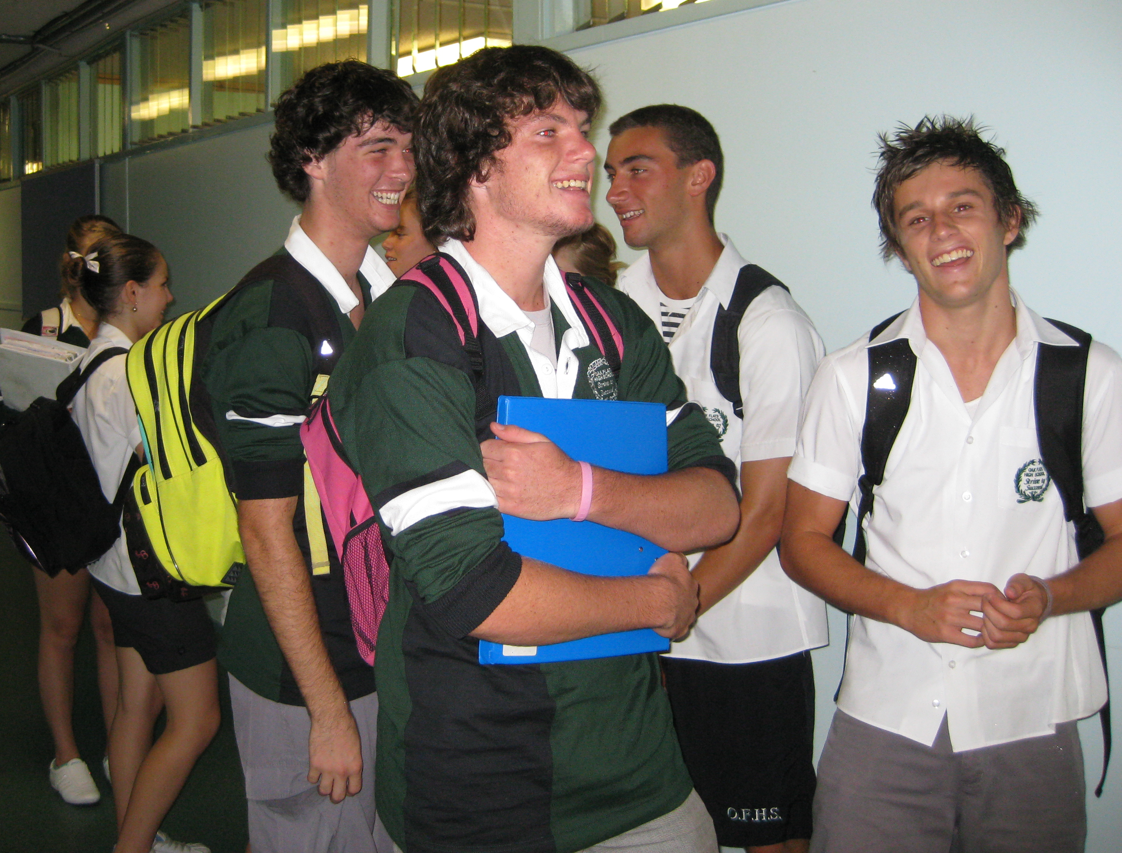
- Wait outside the classroom until your teacher arrives.
- Have your book, pencil case & diary ready with you.
- Enter the classroom & walk directly to your seat. Sit down, place your equipment on your desk and your bag under the desk.
- Wait quietly for the class to begin. (You can review your work from last lesson).

Going to the Toilet

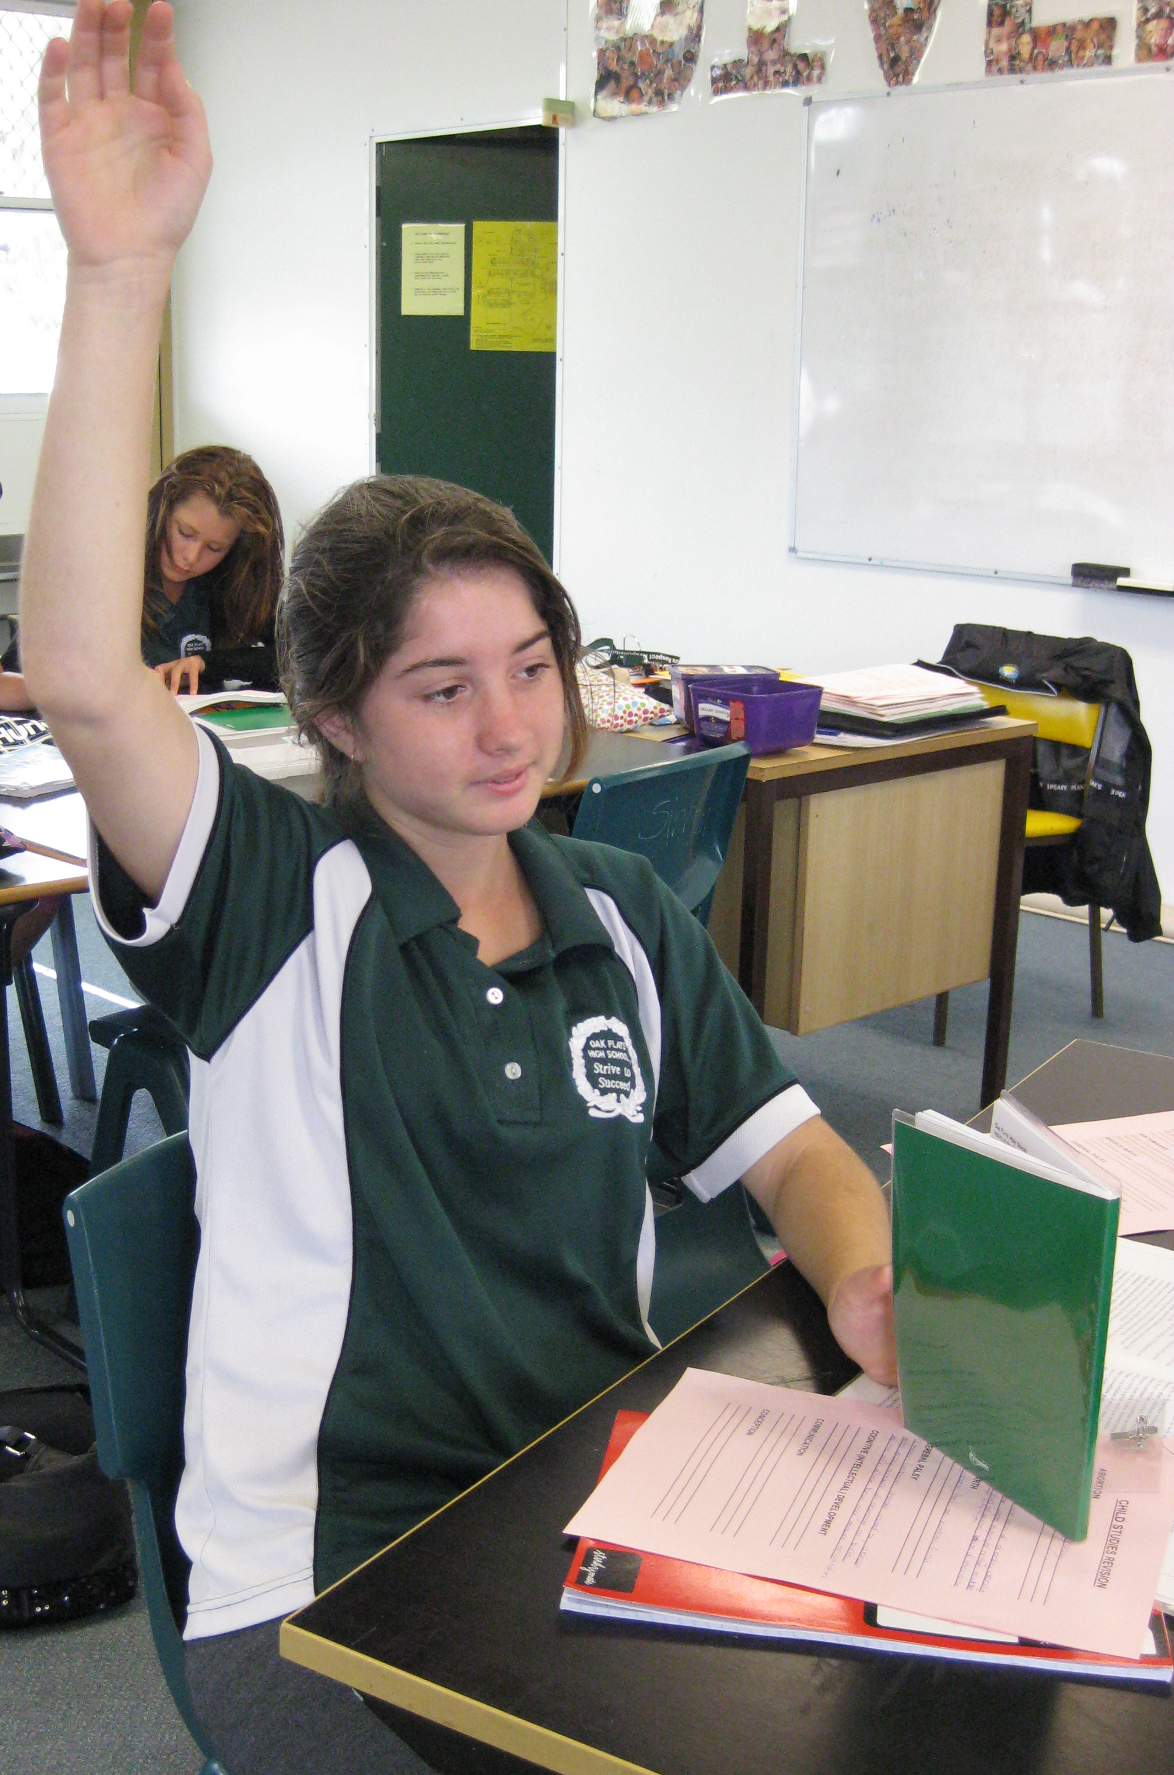
If you need to go to the toilet:-

- Write it in your diary.
- Wait for an appropriate time to ask your teacher. (Right words, right time, right way).
- Have your teacher sign your diary.
- Go directly to the office for the key.
- Return immediately to class, enter quietly and sit back in your seat.

Asking for Help

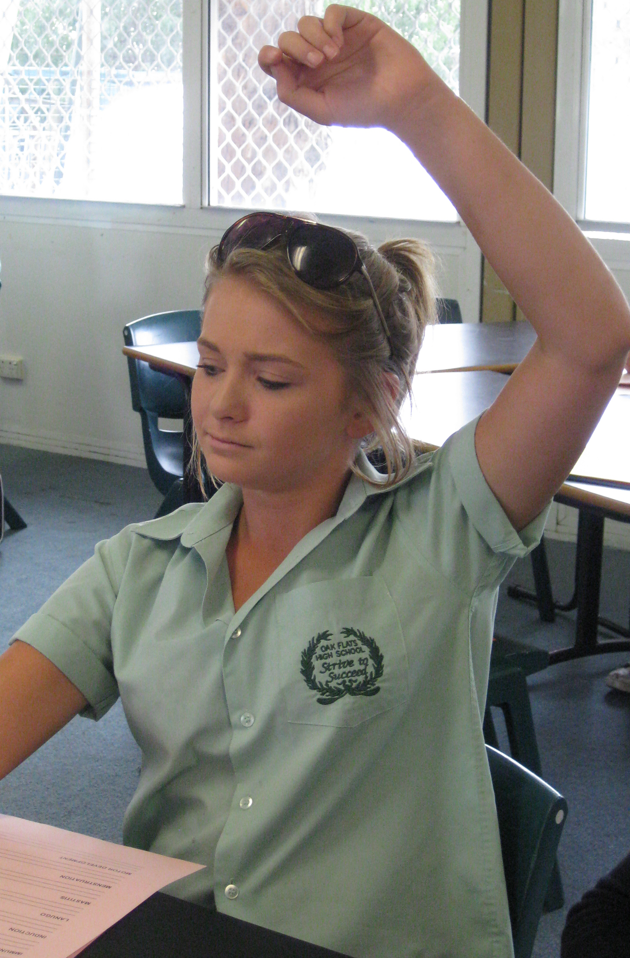

- Always try by yourself first.
- Put your hand up to get the teacher’s attention.
- Keep working if you can, or wait quietly.
- Remember the teacher has other students that may also need help.
- Have your question ready. (Write it down if you need to).
- Listen carefully.
- Say ‘thank you’ for the help and get back on task.

Working Independently

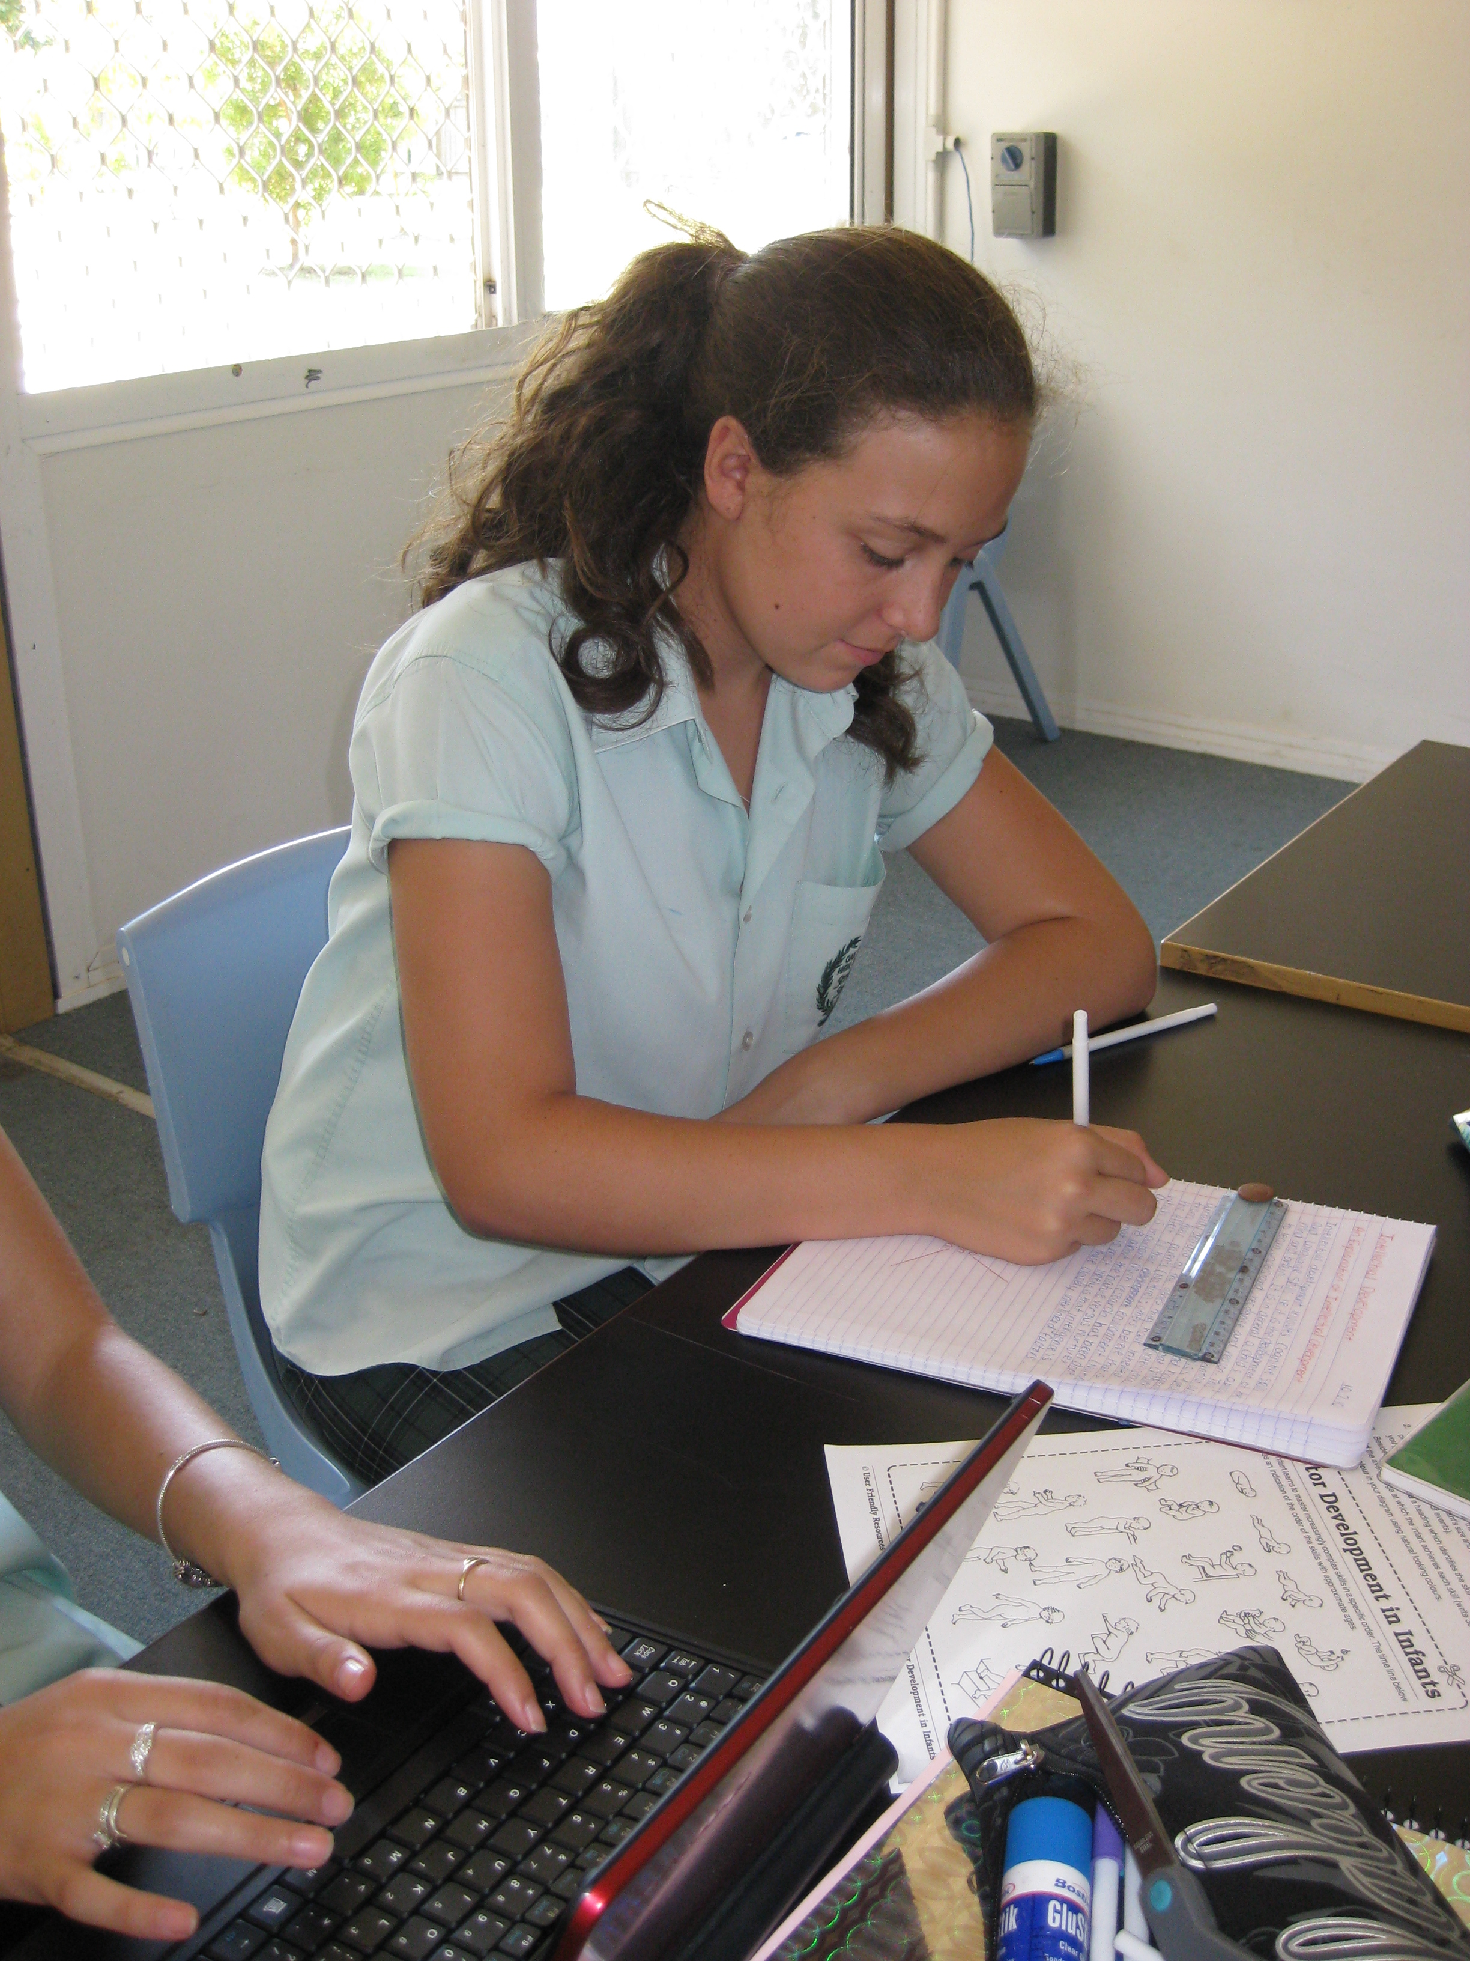
- Sit in your designated seat with equipment on the desk.
- Work without talking to others.
- If you need help, put your hand up to get the teacher’s attention.
- Keep working if you can, or wait quietly. Remember the teacher has other students that may also need help.
- Move quietly around the room when necessary.
- Return materials when finished.

Group Work

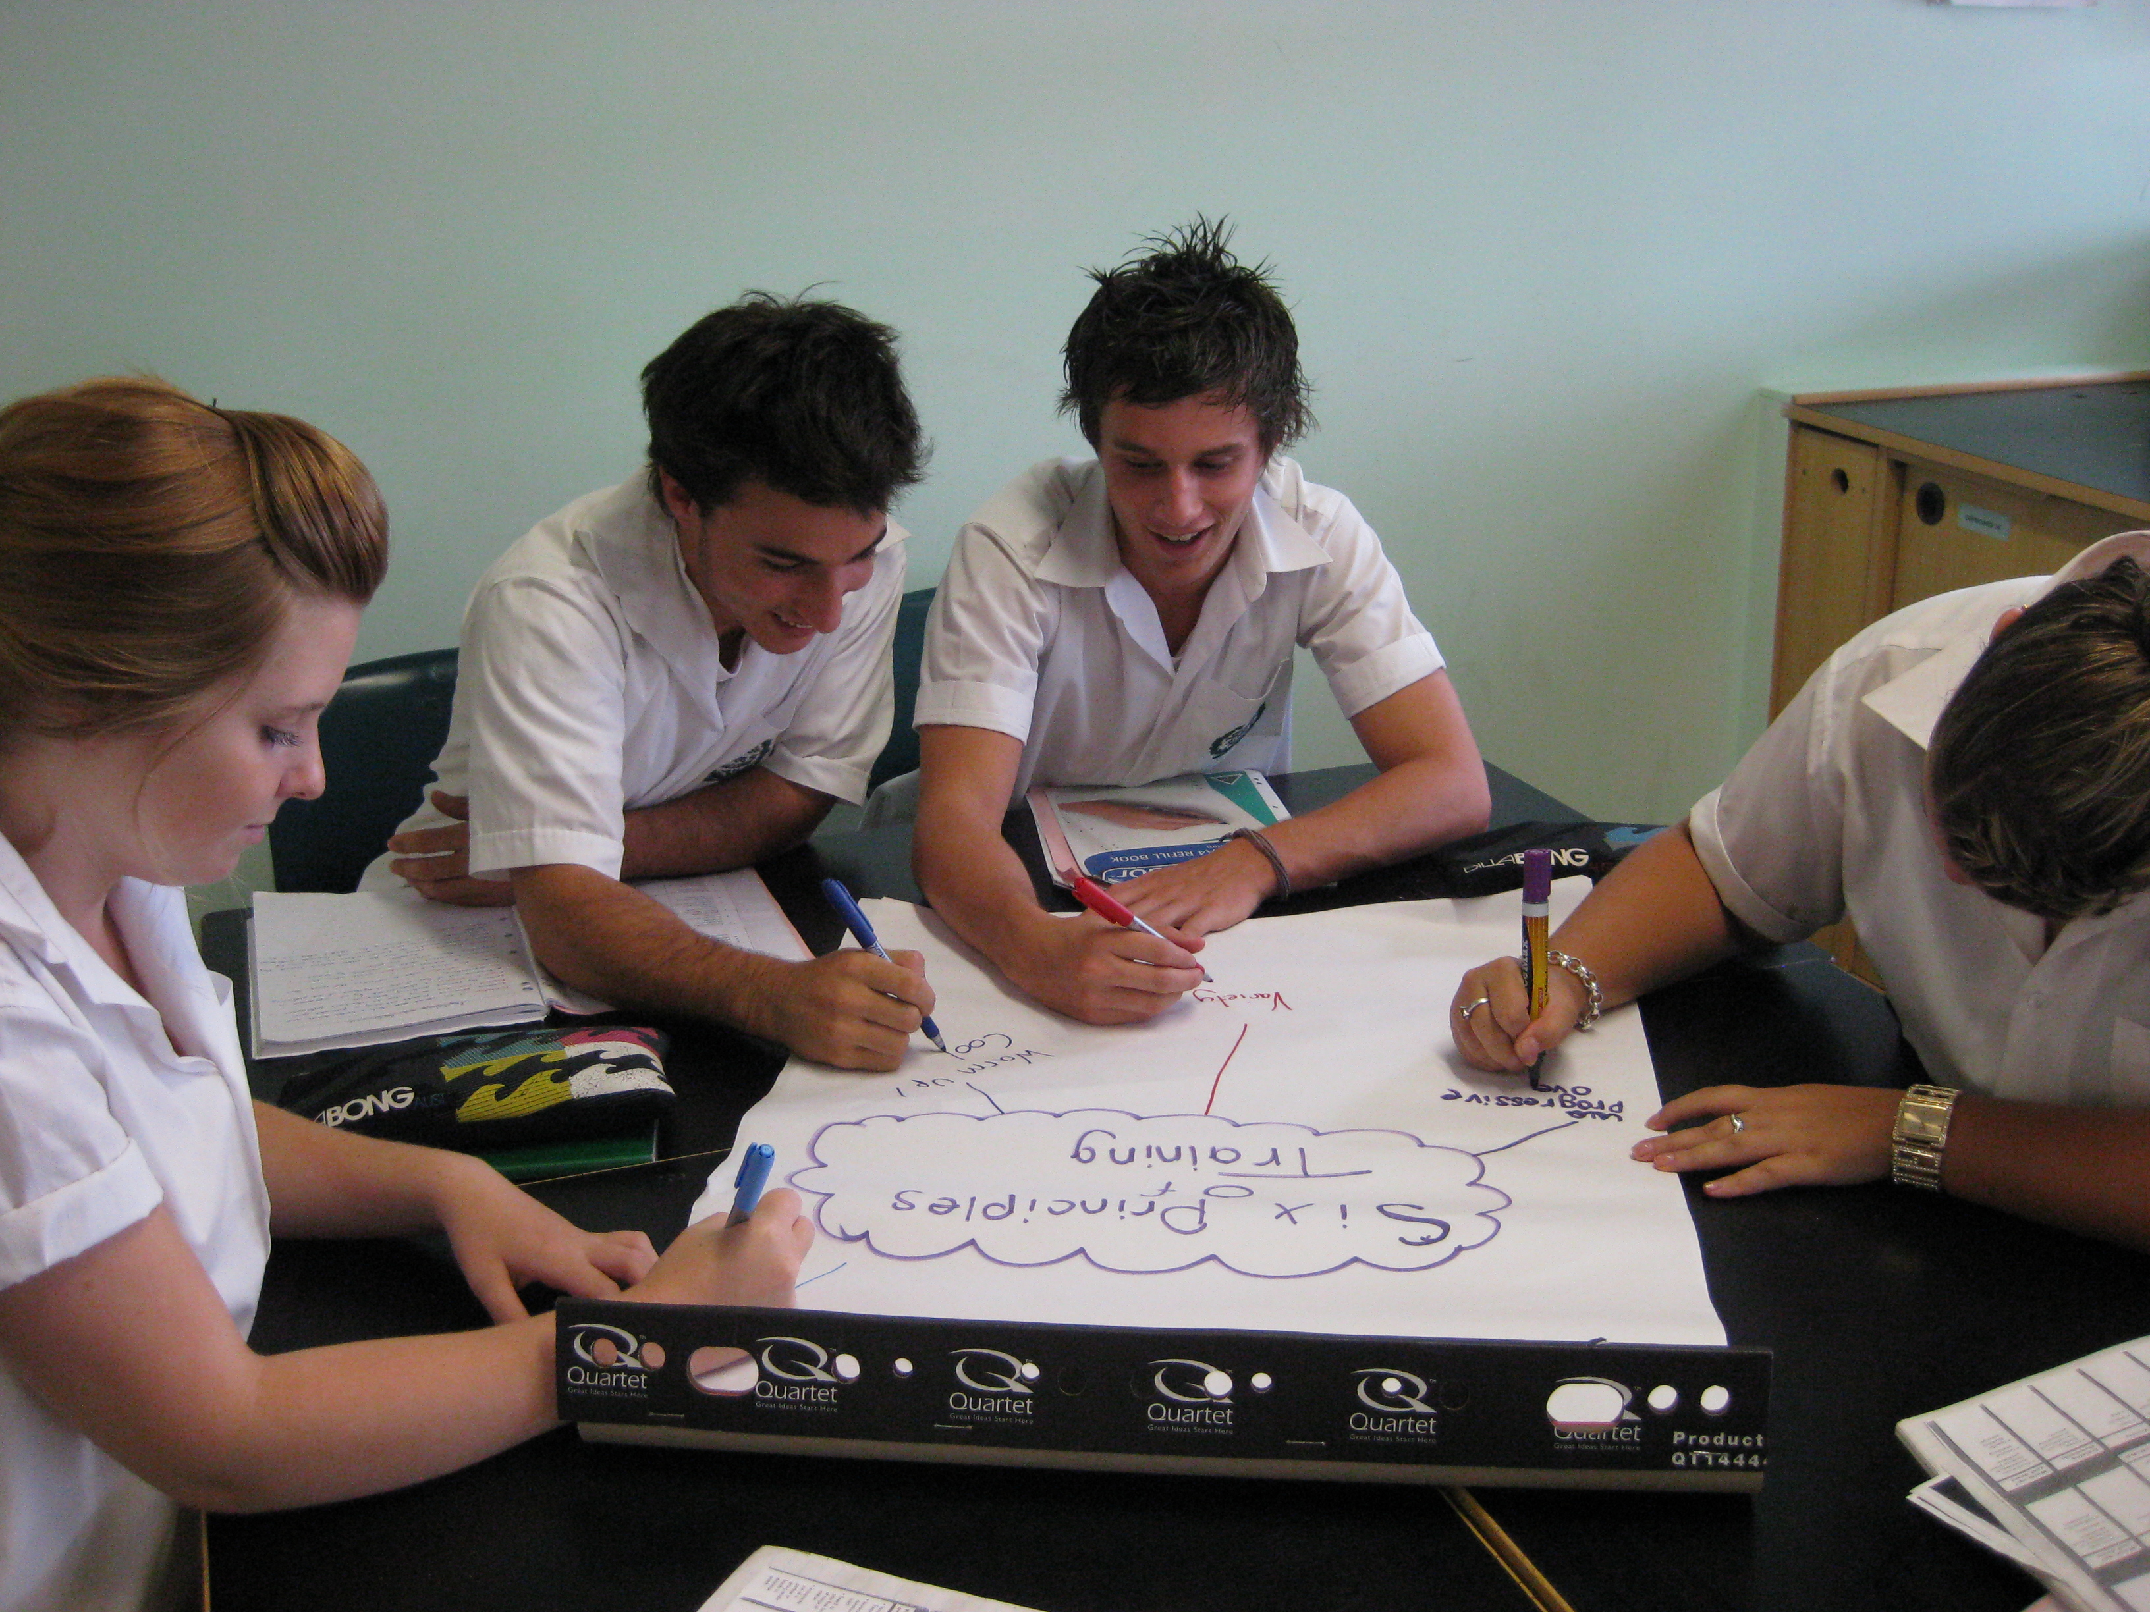
- Work with your designated
group.
- Communicate task to all members of the group.
- Assign roles and start task.
- Listen to others and speak politely.
- If you need help, put your hand up to get the teacher’s attention.
- Keep working if you can, or
wait quietly. Remember the
teacher has other students that
may also need help.
- Move quietly around the room
when necessary.
- Return materials when finished.

Using My Diary

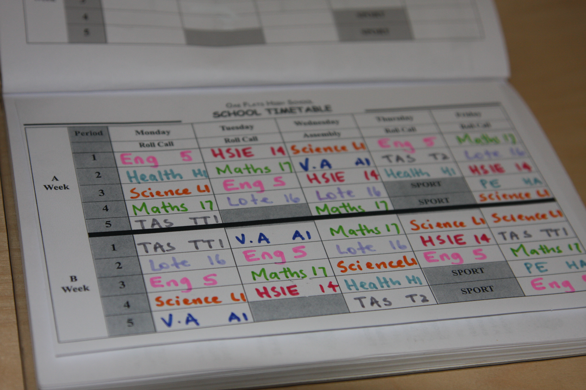
- Place your diary on the desk at start of lesson.
- Record all homework and class assessments in your diary when you get them.
- Record social activities in your diary. (Both in and out of school).
- Look at your diary every afternoon.
- Check off tasks as you complete them.
- Use your diary and timetable to pack your school bag.

TAKE OFF

TURN OFF

PACK AWAY


